Analyse the AGD needs of Women and Girls from indigenous communities
AGD Groups  Thematic Areas | Girls  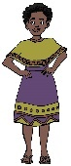  0 -12 | Girls  13 - 18  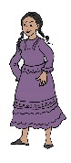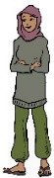 | Women  19 – 24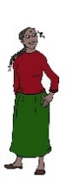 | Women  25-50  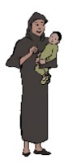  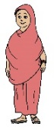 | Older  Women  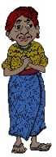 | LBTI  Women & Girls  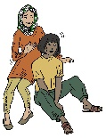 | Women & Girls with a disability  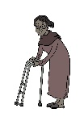
1 Incidence of SGBV  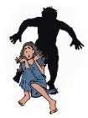 | 1.1 Key issues identified: | 1.2 Key issues identified: | 1.3 Key issues identified: | 1.4 Key issues identified: | 1.5 Key issues identified: | 1.6 Key issues identified: | 1.7 Key issues identified:
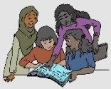  2 Barriers to access to Education | 2.1 Key issues identified: | 2.2 Key issues identified: | 2.3 Key issues identified: | 2.4 Key issues identified: | 2.5 Key issues identified: | 2.6 Key issues identified: | 2.7 Key issues identified:
3 Responsibility & Burden Sharing incl. Refugee Participation & Capacity Building  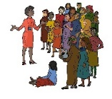 | 3.1 etc
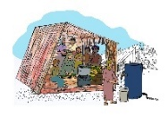
4 Barriers to Energy & Infrastructure, incl. health, shelter, WASH facilities food and water
5 Strengthening Protection Capacity incl. protection from violence, GBV, discrimination, documentation and data collection
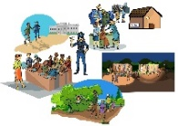
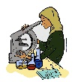
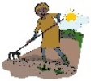
6 Jobs & Livelihoods
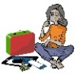
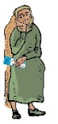
7 Barriers to Facilitating Solutions

